Q1 - UCB
Q1 - Upper Confidence Bound (UCB) Algorithm Analysis

The UCB algorithm was implemented using Python. The following command was used to run the program: python3 q1.py > output.txt

Our program iterates through 8 unique values of C to test the parameter, which is used to scale the “bonus” added to each arms’ expected value. The greater the value of C, the more exploration, and less exploitation will be observed by the agent with the environment.

For each value of C, we let the agent interact with 100 different environments, with 5000 steps per environment. For each environment, new randomized true-values between 0 and 1 are assigned to each arm. The algorithm first explores each arm and updates the expected value for that arm based on the reward (0 or 1) that it receives upon exploration. For the remaining 4990 steps, the UCB algorithm is implemented to achieve the highest average reward.

The average reward and average optimal action % was then normalized across all 100 environments, and plotted using Matplotlib. Results for Average Reward and Average Optimal Action % are shown in Figure 1 and Figure 2 below. For raw data, refer to output.txt.

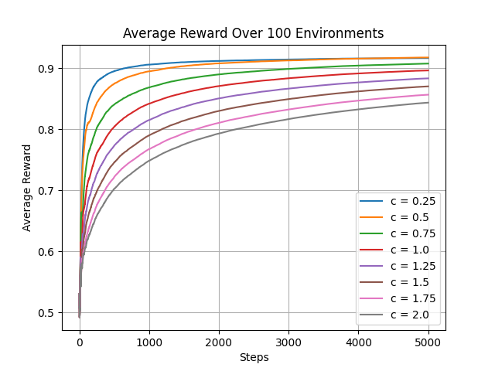
Figure 1 - Average Reward Over 100 Environments, 5000 Steps

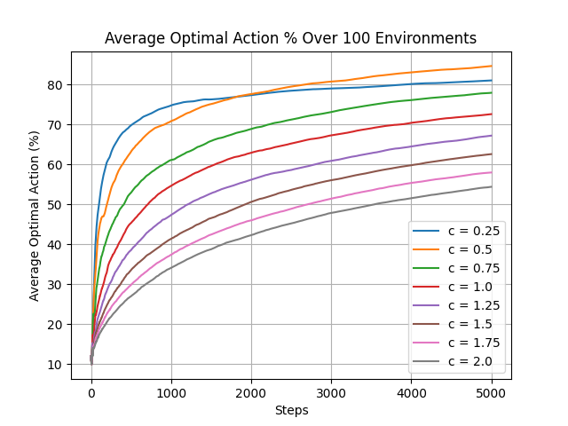
Figure 2 - Average Optimal Action (%) Over 100 Environments, 5000 Steps

As illustrated in Figure 1 and Figure 2 above, it is clear that smaller values for the parameter, C, lead to larger average rewards and converge much faster to yield this higher reward. Specifically, C=0.5 leads to the greatest average reward of 0.9174, as well as the highest average optimal action % of 84.61% (see output.txt for raw data).

However, larger values of C converge more slowly as they continue exploring suboptimal arms, and thus yield a lower average reward. Hence, a higher C value encourages the exploration of less explored arms but does not yield the best result. Specifically, C=2.0 seems to produce the lowest average reward and average optimal action % of 0.8434 and 54.39% respectively.

In Figure 1 the slopes for C=0.25 and C=0.5 are much steeper in the first 1000 steps, and level off after 1000 steps illustrating faster convergence towards a higher average reward.
It is interesting to note that in Figure 2, C=0.25 seems to perform the best in terms of selecting the optimal arm for the first 2000 steps. However, after 2000 steps, C=0.5 outperforms C=0.25 which could indicate that slightly more exploration than exploitation leads the agent to choose the optimal arm more frequently. In other words, heavily exploiting arms based on initial expected values without encouraging much exploration will not lead to optimal results.
To further explore the behaviour of the algorithm and how well it can select the optimal arm, we tested with C = 0.25, 0.50, 0.75 for 100 environments with 50,000 steps each. Figure 3 below illustrates the results.

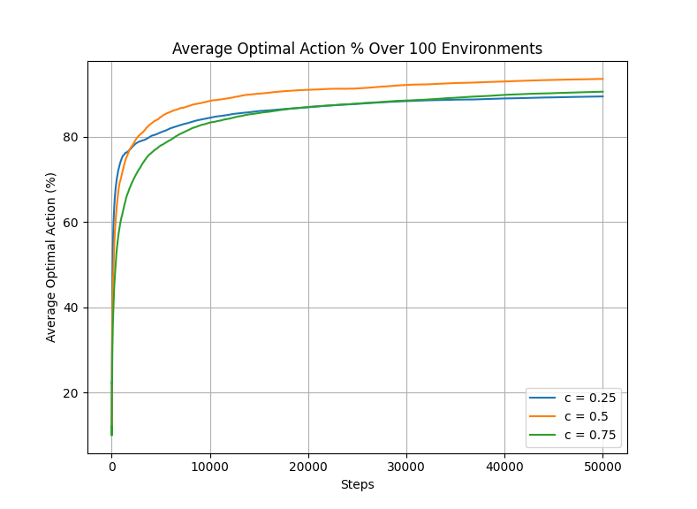
Figure 3 - Average Optimal Action (%) Over 100 Environments, 50,000 Steps

It is evident that C=0.5 is the best choice for the UCB algorithm as it selects the optimal arm the most, outperforming C=0.25 after the first 2000 steps as explained above. However, C=0.75 also outperforms C=0.25 after roughly 30,000 steps. This suggests that a C value of 0.5 to 0.75 is ideal.

Therefore, based on our findings, the UCB algorithm performs best when using a tuning parameter in the range C=0.5-0.75, with optimal results using C=0.5. This encourages the right amount of exploration throughout the interactions so the agent doesn’t waste time exploring too many sub-optimal arms, without fostering a bias early on towards any particular arm.

Q2 - LRI & LRP vs UCB

Q2 - Linear Reward Inaction (LRI) and Linear Reward Penalty (LRP) vs UCB Algorithm Analysis

The UCB algorithm was implemented using Python. The following command was used to run the program: python3 q2.py > output2.txt

All the graphs shown below have been generated by the implementation. Note that some graph generation code has been commented out in the code file for more clarity.

Performance Analysis of LR-P

- Average Reward

Within the first 500 to 1000 steps in each environment, all configurations show rapid initial learning. Then all graphs reach a plateau. The results clearly show that the choice of α (learning rate) and β (penalty rate) has a strong effect on final performance.

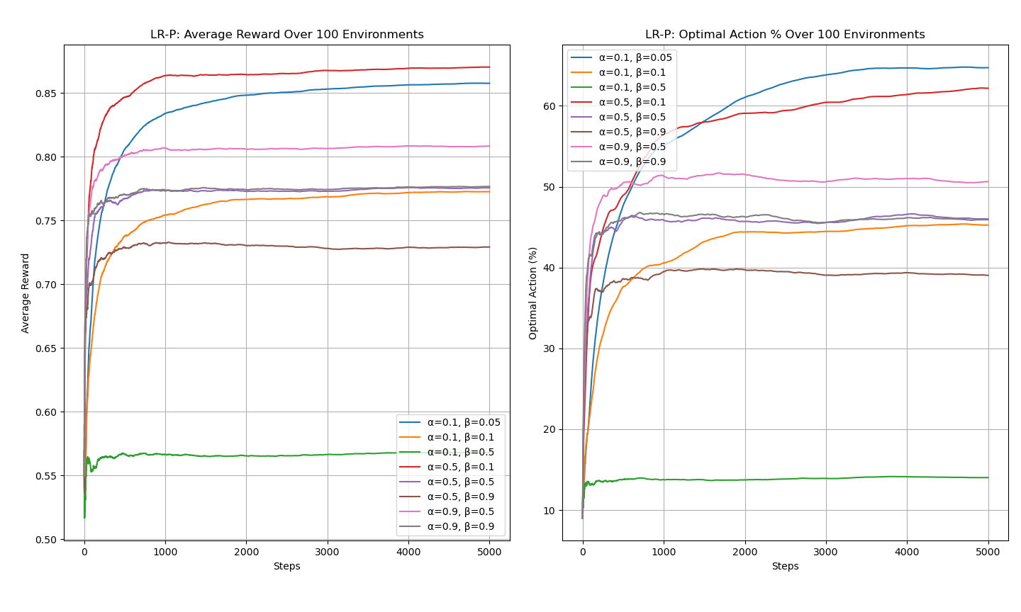
Best results seems to be α = 0.5, β = 0.1 with final reward of approximately 0.87. The second best performance is for α = 0.1, β = 0.05, with final reward of approximately 0.86. Both these graphs are more stale and faster in learning compared to others.

Moderate results are for
α = 0.9, β = 0.5, α = 0.5, β = 0.5,
α = 0.9, β = 0.9, α = 0.1, β = 0.1 and
α = 0.5, β = 0.9 with rapid early improvements but peaking lower in range of 0.73 ~ 0.81. These approaches show excessive penalty (higher β) will decrease learning quality.

α = 0.1, β = 0.5 with lowest reward, indicates that higher penalty rate plus a low α will significantly restrict learning.

- Optimal Action Percentage


All graphs show a steep early curve, however, later improvements are gradual, emphasizing on exploitation rather than exploration.

Best results seem to be α = 0.1, β = 0.05 with highest optimal action around 65%, indicating long term exploitation. Then α = 0.5, β = 0.1 graph peaking around 62%, balances exploration and exploitation.

Moderate results are for α = 0.9, β = 0.5, with early peak but gradual decline, showing instability and α = 0.5, β = 0.5, α = 0.9, β = 0.9 and α = 0.1, β = 0.1 stabilizing around 45% ~ 47%.

The configuration α = 0.5, β = 0.9 performs poorly, dropping below 40%, indicating that an excessively high penalty rate harms decision quality. The worst result is again observed for α = 0.1, β = 0.5, which barely reaches 14%, consistent with its poor performance in the average reward results.

- Conclusion

Overall, the results show that moderate learning rates and low penalty values lead to the best performance for LR-P. In particular, α = 0.5, β = 0.1 provides the best overall balance, achieving the highest average reward while maintaining a strong optimal action rate. While α = 0.1, β = 0.05 performs slightly better in terms of optimal action percentage, it converges more slowly. In contrast, high penalty rates (β ≥ 0.5) consistently degrade performance, especially when combined with low learning rates.

Performance Analysis of LR-I

Similar to LR-P, LR-I shows rapid initial learning within the first 500 to 1000 steps, followed by a plateau, showing convergence. The results demonstrate that the choice of learning rate α has a strong impact on both learning speed and final reward.

- Average Reward

The best performance is achieved by α = 0.5, reaching the acreage reward of 0.9. This setting learns quickly and remains stable during the training period. The second best learnings are α = 0.01 with a final reward around 0.88 even though the learning progress was slower, and α = 0.1 with strong long term performance and fast convergence.

Higher learning rates, including α = 0.3, 0.5, 0.7, 0.9, and 0.95, result in lower final rewards, typically between 0.70 and 0.75. Although these settings show quick early improvement, they converge prematurely, indicating that overly large learning rates reduce learning quality.

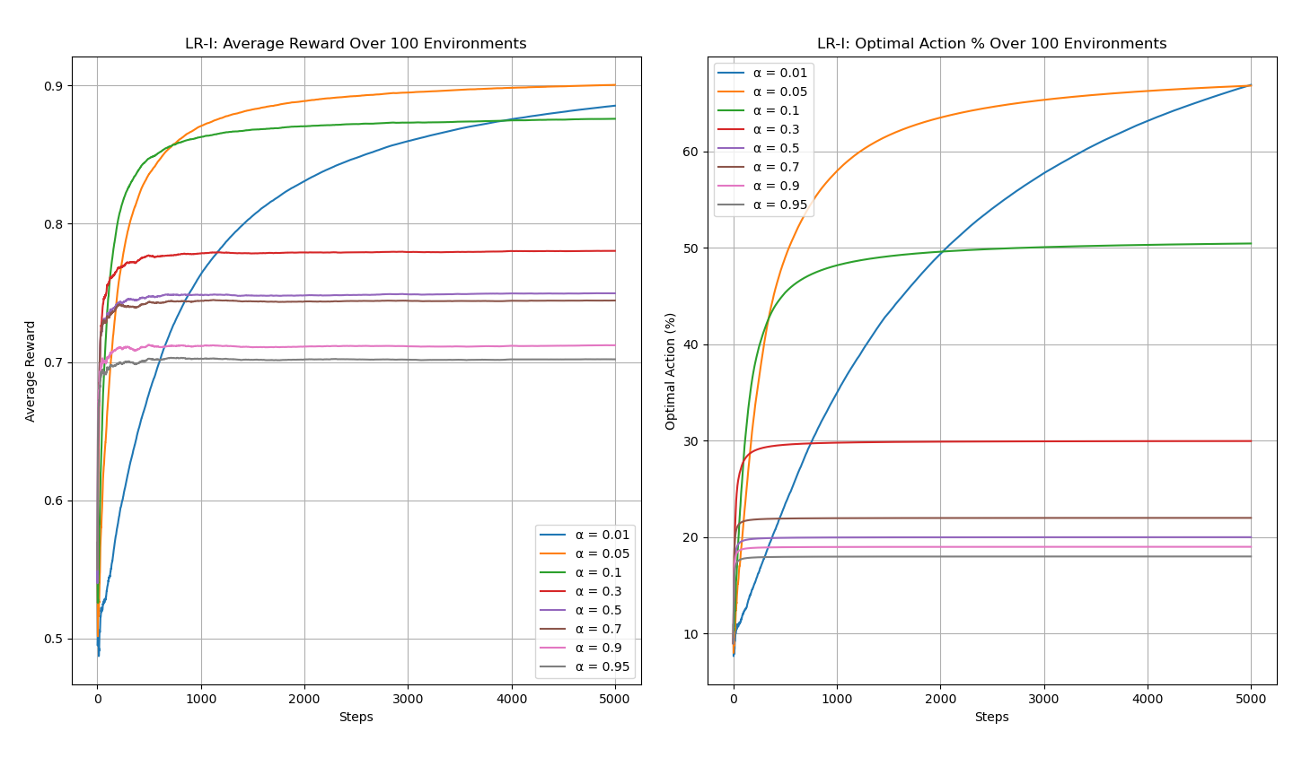

- Optimal Action Percentage

All learning rates show a steep increase in optimal action selection early in training, followed by slower, more gradual improvements, reflecting a transition from exploration to exploitation.
The highest optimal action percentage is achieved by α = 0.05 and α = 0.01, both reaching approximately 66–67% by the end of training. While α = 0.01 improves more slowly, it continues to increase steadily and eventually matches the best-performing configuration.
The learning rate α = 0.1 achieves a moderate optimal action rate, stabilizing around 50%, indicating reasonable but limited exploitation. The configuration α = 0.3 plateaus early at around 30%, suggesting insufficient long-term improvement.
Higher learning rates (α ≥ 0.5) perform poorly, stabilizing between 18% and 22%. These results show large learning rates lead to unstable updates and prevent the algorithm from consistently selecting optimal actions.

- Conclusion

Overall, the LR-I results show that small to moderate learning rates lead to the best performance. In particular, α = 0.5 provides the best balance between fast convergence, high average reward, and strong optimal action selection. While α = 0.01 achieves similar long-term performance, it converges more slowly. In contrast, large learning rates (α ≥ 0.5) consistently degrade both reward and decision quality, causing poor exploitation.

Algorithm Comparison
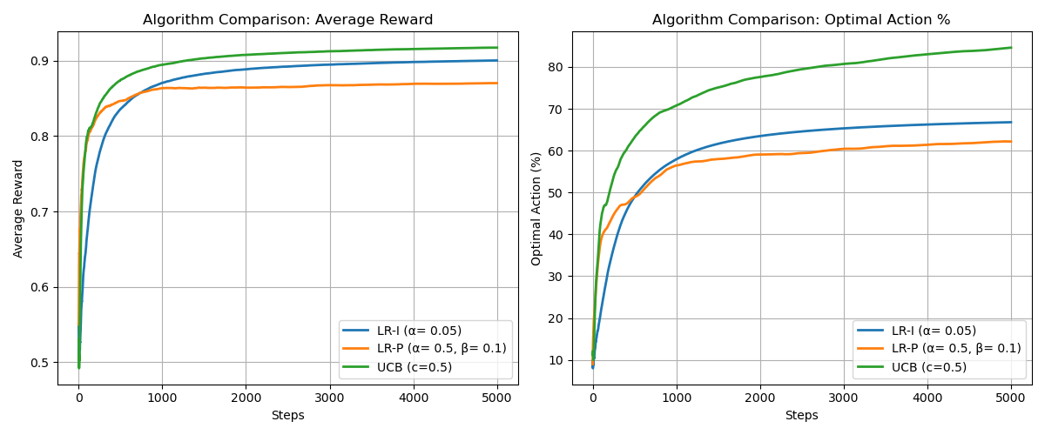
Among the three methods, UCB is the fastest and most effective overall. It shows very rapid learning in the early stages, reaching an average reward of about 0.88 within the first few hundred steps and continuing to improve to a final reward of approximately 0.91–0.92. UCB also achieves the highest optimal action percentage, exceeding 80% by the end of training, which indicates strong and consistent exploitation of the best actions.

LR-P learns faster than LR-I early on, reaching a stable reward of around 0.86–0.87 relatively quickly, but it plateaus early and does not improve much afterward. Its optimal action percentage stabilizes at approximately 62%, which is lower than both UCB and LR-I.



LR-I starts more slowly, with gradual improvement during the early steps, but it continues learning throughout training and eventually reaches an average reward close to 0.90. Its optimal action percentage also improves steadily, reaching around 67% by the end. Overall, UCB provides the best balance between fast convergence and strong final performance, followed by LR-I, while LR-P performs well early but falls behind in long-term results.

